Detection of Cardiovascular Disease by ECG Images Using LSTM

Authors
S. Rajesh
Dept. of Computer Science and Engineering, V R Siddhartha Engineering College srajesh@vrsiddhartha.ac.in
*Meeniga Nandini
Dept. of Computer Science and Engineering, V R Siddhartha Engineering College nandinimeeniga18@gmail.com
Medagam Rahithya
Dept. of Computer Science and Engineering, V R Siddhartha Engineering College medagamrahithya@gmail.com
P. Naga Lokesh Chowdari
Dept. of Computer Science and Engineering, V R Siddhartha Engineering College loki.patibandla@gmail.com

Abstract
Through the analysis of electrocardiogram (ECG) images, this study explores the application of machine learning and deep learning techniques for the early identification of cardiovascular illnesses. We evaluate the efficacy of conventional algorithms and cutting- edge deep learning techniques using a variety of datasets, preprocessing techniques, and feature extraction approaches model like the LSTM. While robustness is ensured by validation on separate datasets, the application of transfer learning improves model generalization. A focus on interpretability seeks to promote clinical acceptance, which is essential for incorporating new techniques into standard medical procedures. Overall, this study shows how these methods have the potential to transform the diagnosis of cardiovascular disease, allowing for prompt interventions and ultimately leading to better patient outcomes. Additionally, by permitting preemptive therapies, this interdisciplinary approach holds promise for revolutionizing cardiovascular healthcare.

Keywords
Cardiovascular disease, Diagnosis, Machine learning, Deep learning, Electrocardiogram (ECG),LSTM

INTRODUCTION
This study aims to combine deep learning and machinelearning methods for the early identification of cardiovascular disorders by electrocardiogram (ECG) picture processing,

providing a novel means of advancing medical science. By means of the incorporation of varied. It aims to performa complete comparison examination of the diagnostic effi-cacy between conventional methods and state-of-the-art deep learning models, notably Long Short-Term Memory (LSTM) network, using datasets, preprocessing procedures, and feature extraction techniques. This project establishes the foundation for a comprehensive study of cardiovascular health analytics with the goal of expanding the limits of existing diagnostic capabilities.
The proposed methods are validated on various datasetsto ensure that they work reliably in different settings. The research’s emphasis on the potential to transform the diagnosisof cardiovascular illness highlights its dedication to facilitating prompt interventions and ultimately enhancing patient out- comes, so influencing the trajectory of cardiovascular health- care in the future.
A. ECG signal

The electrical activity of the heart is displayed on an ECG signal. Doctors can see if the heart is beating correctly becauseto the waves it produces. Through the use of these waves, cardiac issues can be identified.
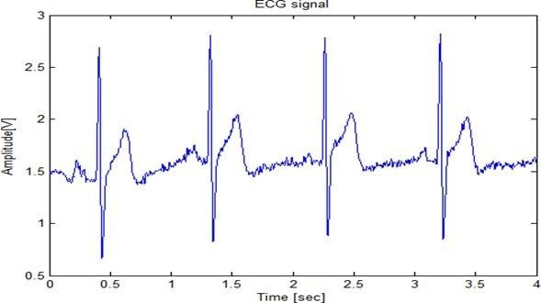

Fig. 1. ECG Signal with PQRST Dimensions

B. Abnormal ECG Signal
Abnormal ECG signals include various cardiac anomalies such as arrhythmias, ischemia, and conduction disorders. Unusual P or T waves, aberrant QRS length or shape, and extended PR or QT intervals are examples of anomalies that can be seen in an abnormal ECG signal. It may be a sign of anelectrolyte imbalance, myocardial infarction, ischemia, or ar- rhythmias. Abnormal wave shapes or ST elevation/depression are common anomalies. For a proper diagnosis and courseof therapy, these variations call for additional medical assessment.

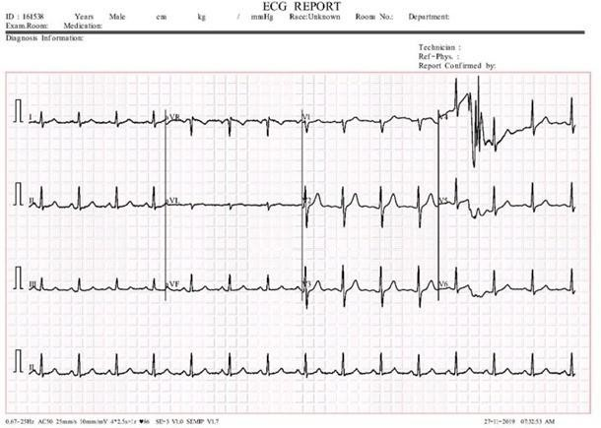

Fig. 2. Abnormal ECG Signal

C. Normal ECG signal
Normal ECG signals exhibit regular patterns representing healthy cardiac activity. P waves represent atrial depolarization,QRS complexes represent ventricular depolarization, and T waves represent ventricular repolarization in a typical ECG signal. The QRS length should be ¡ 0.12 seconds, and thePR interval should be 0.12-0.20 seconds. The normal rangefor heart rate is 60–100 bpm. Any differences might point to irregularities in the heart.
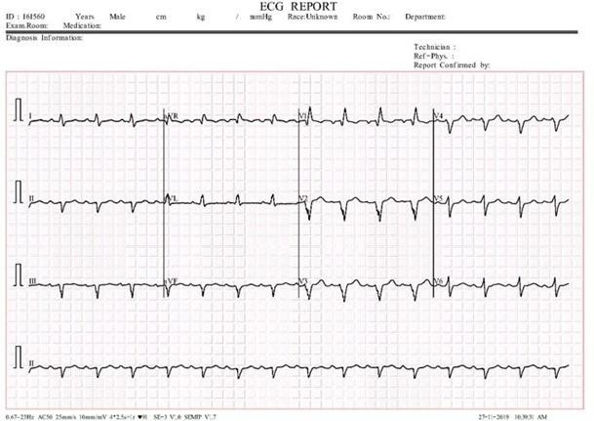

Fig. 3. Normal ECG signal

RELATED WORK
The study by Abubaker and Babayi builds on previous research [1] that used conventional approaches for cardiovascular disease identification, by employing machine learning and

deep learning to advance ECG image interpretation. By combining deep learning techniques and sophisticated algorithms, their strategy outperforms conventional methods and simpler models in terms of accuracy.
Ullah and colleagues improve the identification of cardiovascular illness [2]by fine-tuning feature selection in machine learning models. By using more relevant feature sets to improve accuracy, this work advances earlier techniques.
By incorporating cutting-edge device getting to know techniques, Gupta et al. (2019) present MIFH [3], a system intelligence framework for diagnosing heart ailment that improves on previous procedures. Compared to conventional models, their technique increases diagnostic performance and accuracy. Ahmad and Polat recommend a coronary heart sickness prediction model [4]version utilizing a jellyfish optimization algorithm combined with gadget studying. This method enhances prediction accuracy and performance, building on previous optimization and system getting to know techniques for scientific diagnostics. Ullah et al. (2022) use more advantageous characteristic selection techniques to provide an powerful machine mastering model for early and correct cardiac disorder prediction. Their technique improves on previous models by using using superior feature optimization to boom prediction accuracy and early detection skills. Sailasya and Kumari (2021) investigate the fulfillment of device learning classification methods [5] in stroke prediction. Their research compares numerous models’ efficaciousness for you to improve forecast accuracy and dependability

BACKGROUND WORK
Improving early detection of cardiac disease necessitates the employment of machine learning algorithms [2], [4] that employ electrocardiogram (ECG) readings with finely calibrated feature selection. The data utilized in the study was collected from a number of hospitals. Images of the heart architecture and blood flow were captured utilizing MRIs, CT scans, or ultrasounds to offer detailed images. Patient consent was obtained when needed during the data gathering procedure, in accordance with ethical requirements. The dataset supports cardiovascular health research by including imaging parameters, clinical information, and patient demographics.The purpose of cardiovascular disease detection is to ensure the precise and timely diagnosis of coronary heart abnormalities. The system is created by combining two prominent pre-trained models, VGG16 and LSTM, which are well-known for their success in image categorization assignments.The system leverages its vast feature extraction capabilities by merging the results of both models.The pre-trained VGG16 model was adjusted for binary classification of cardiovascular disease following initial training on the ImageNet dataset.All of the VGG16 layers were frozen in order to make use of its learned characteristics. Bespoke classification layers were added, starting with a flattening layer, followed by two dense layers triggered by ReLU and a third dense layer activated by sigmoid for binary output.The Adam optimizer was used to build the model, using a binary cross- entropy loss and a learning rate of 0.0001. Accuracy was assessed by combining VGG16 feature extraction with specific classification layers to efficiently identify cardiovascular

ailments. Given that LSTM (Long Short Term Memory) networks can capture long-term dependencies in sequential data, they are an effective option for ECG image interpretation.LSTM models examine time-series data at the pixel level in ECG images to detect complicated temporal patterns that indicate cardiac health.LSTMs may discover minute changes and irregularities in the cardiac cycle by reading each ECG image as a sequence of pixels, facilitating accurate diagnosis.These networks, trained on sequential data, are particularly successful in detecting anomalies like cardiac arrhythmias or ischemia episodes.LSTMs employ memory cells to consistently extract and categorize features by keeping essential information over time steps.

METHODOLOGY
The first step is to get the raw ECG data, which depicts the heart’s electrical activity.Noised ECG signals are created by filtering raw signals to remove artifacts, baseline drift, and noise.The VGG16 convolutional neural network is used to extract excessive-degree features from denoised ECG data. The most relevant skills for categorizing and characterizing cardiac events are identified using feature selection procedures.The chosen properties were loaded into an LSTM algorithm, which is a type of recurrent neural network capable of processing sequential data.The LSTM model simplifies the process of accurately forecasting cardiovascular events by finding temporal correlations and patterns in ECG data. Finally, the trained LSTM model is used for prediction tasks, offering valuable insights on heart health and supporting medical decision-making.
Raw ECG data often show a waveform representing the heart’s electrical activity over time.These indicators, with three separate waveforms (Pwave, QRS complex, and Twave), mimic the atria and ventricles’ depolarization and repolarization processes.Raw data, including waveforms, intervals, and amplitudes, is vital for diagnosing cardiac problems such as ischemia, myocardial infarctions, and arrhythmias.Accurate interpretation of raw ECG signals is necessary for clinically assessing and treating heart-related diseases.

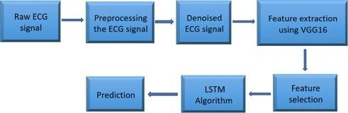

Fig. 4. Methodology

Preprocessing the ECG signal

The collected ECG images vary in size, contrast, and sharpness levels. Filtering removes baseline float and noise from the dataset, ensuring signal clarity and standardization. Separating signals into heartbeats or intervals simplifies feature extraction. To provide consistency, normalization standardizes signal amplitudes across recordings.

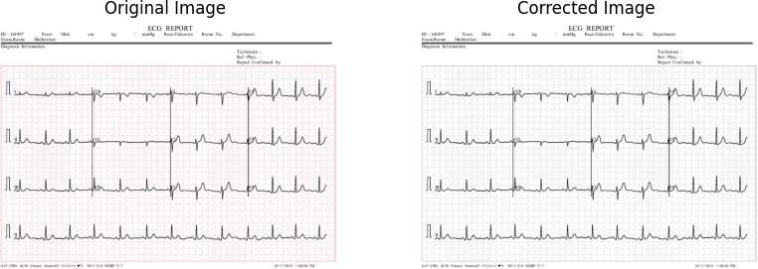

Fig. 5. Original and adjusted ECG signal pictures

Using Wavelet Transform to remove noise from ECG data involves breaking down the sign into frequency components, identifying patterns in the noise at different scales, and filtering out particular noise while preserving significant ECG charac- teristics.Noise distortions such as baseline drift and muscle interference can be minimized by thresholding wavelet coefficients and reconstructing the signal.Wavelet denoising is a versatile approach for improving the quality of ECG recordings, allowing for accurate diagnosis and analysis of inclinical conditions.
Feature Extraction

VGG16 function extraction uses a pretrained model trained on the ImageNet dataset to extract high-level functions from images. Load VGG16 without its pinnacle class layers and select an output from an advanced convolutional layer for analysis. The photo is loaded, scaled to 224 pixels, turned into an array, and preprocessed to meet VGG16’s entry conditions. The version extracts characteristic maps from preprocessed photographs. If necessary, these function mappings can be flattened to form a one-dimensional function vector. VGG16’s powerful feature extraction capabilities may be used for many tasks such as object recognition, image classification, clustering, and more.
Using VGG16’s powerful feature extraction capabilities may be used [3].is useful because it uses the pretrained version’s convolutional layers to extract complex, hierarchical capabilities from ECG recordings. This method enhances accuracy in identifying cardiovascular problems, decreases the need for large labeled datasets, and increases generalization to new data. VGG16 automates characteristic extraction, making the evaluation process more efficient and effective in diagnosing coronary heart problems.

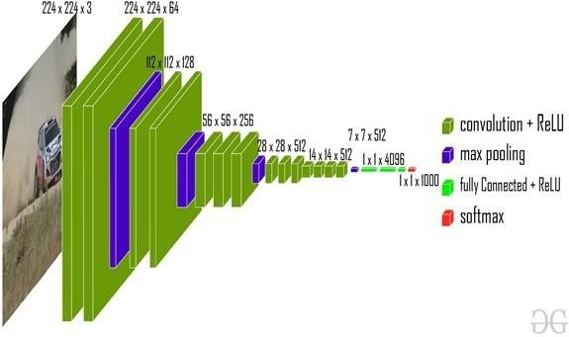

Fig. 6. VGG16 Architecture

LSTM Algorithm

LSTM, a recurrent neural network, is used to diagnose cardiovascular diseases by analyzing sequential data such as ECG signals. It excels at capturing long-term dependencies, which are crucial for understanding the context of cardiac rhythm abnormalities. LSTM networks are trained on annotated ECG datasets to accurately discriminate between normal and abnormal cardiac rhythms. This assists clinicians in early identification and diagnosis of many cardiovascular diseases. LSTM’s ability to process temporal data makes it a valuable tool for improving diagnostic abilities and patient outcomes in cardiovascular healthcare. LSTM networks may detect patterns and spatial relationships in photos by considering them as sequential recordings during image processing.
LSTM, a recurrent neural network, is used to diagnose cardiovascular diseases [4]. by processing sequential data such as ECG signals. It captures long-term dependencies, which are critical for recognizing heart rhythm problems. LSTMs are trained on ECG datasets to differentiate between normal and abnormal rhythms, which aids in early analysis. Their capacity to process temporal information improves diagnostic skills in healthcare. Furthermore, in image processing, LSTMs can detect spatial patterns by considering images as sequences, which aids with tasks such as classification and segmentation by determining relationships throughout an image.

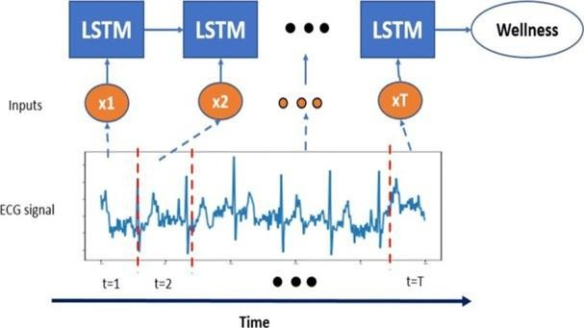

Fig. 7. LSTM Architecture

RESULTS
The input picture provided to the system is displayed in the first column of the table, and the prediction result and confidence are displayed in the second.
A. Performance Analysis
The efficiency of machine learning for ECG image-based cardiovascular disease detection using LSTM and measures like as F1-Score, Accuracy, Precision, and Recall.

𝐴𝑐𝑐𝑢𝑟𝑎𝑐𝑦 =
𝑁𝑢𝑚𝑏𝑒𝑟 𝑜𝑓 𝑐𝑜𝑟𝑟𝑒𝑐𝑡 𝑝𝑟𝑒𝑑𝑖𝑐𝑡𝑖𝑜𝑛

𝑇𝑜𝑡𝑎𝑙 𝑛𝑢𝑚𝑏𝑒𝑟 𝑜𝑓 𝑝𝑟𝑒𝑑𝑖𝑐𝑡𝑖𝑜𝑛

Accuracy is a key performance indicator in machine learning (ML) that is used to assess how well categorization models work. It shows the proportion of successfully predicted cases to all instances that were analyzed. It is simple to calculate accuracy: just divide the total number of forecasts made by the number of right predictions.

𝑃𝑟𝑒𝑐𝑖𝑠𝑖𝑜𝑛 =
𝑇𝑟𝑢𝑒 𝑝𝑜𝑠𝑖𝑡𝑖𝑣𝑒

𝑇𝑟𝑢𝑒 𝑝𝑜𝑠𝑖𝑡𝑖𝑣𝑒 + 𝐹𝑎𝑙𝑠𝑒 𝑝𝑜𝑠𝑖𝑡𝑖𝑣𝑒

especially in assignments it’s critical to accurately identify good examples. The percentage of accurately anticipated positives, or true positives, among all occurrences of positive prediction including false positives and true positives is known as precision.

𝑅𝑒𝑐𝑎𝑙𝑙 =
𝑇𝑟𝑢𝑒 𝑝𝑜𝑠𝑖𝑡𝑖𝑣𝑒

𝑇𝑟𝑢𝑒 𝑝𝑜𝑠𝑖𝑡𝑖𝑣𝑒 + 𝐹𝑎𝑙𝑠𝑒 𝑛𝑒𝑔𝑎𝑡𝑖𝑣𝑒

In machine learning, recall—also referred to as sensitivity or true positive rate—is an
essential parameter for assessing categorization models. It assesses a model’s capacity to

accurately identify every positive case in a dataset—that is, all real positive instances, or true positives. Recall is simple to calculate: just divide the number of true positive predictions by the total of false negatives and true positives.

𝐹1𝑠𝑐𝑜𝑟𝑒 = 2 ×
𝑃𝑟𝑒𝑐𝑖𝑠𝑖𝑜𝑛 × 𝑅𝑒𝑐𝑎𝑙𝑙

𝑃𝑟𝑒𝑐𝑖𝑠𝑖𝑜𝑛 + 𝑅𝑒𝑐𝑎𝑙𝑙

The F1-score is a machine learning data that evaluates a classification model’s balance between recall and accuracy. It is especially helpful in situations when there are serious repercussions for both false positives and false negatives. The harmonic mean of recall and accuracy yields the F1-score.
The presentation named ”Performance Metrics” shows a bar chart comparing four metrics: accuracy, precision, recall, and F1-Score. Each statistic has a score of 80 or higher, indicating strong overall performance. Accuracy: 85, Precision: 88, Recall: 87, and F1-Score: 86. The bars for all indicators are roughly the same height, indicating that the assessed system produces consistent and strong results. This consistency emphasizes the system’s balanced performance, which excels in all critical areas of evaluation.
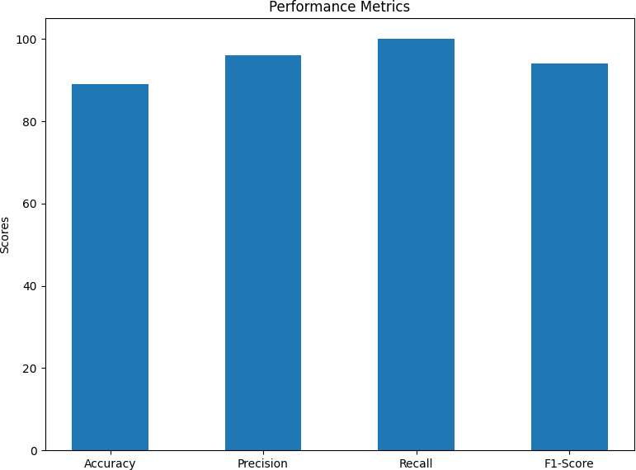

Fig. 8. performance graph

These high ratings represent useful and consistent performance across all measures. The narrow range of values indicates that the system performs well in all critical areas without preferring one over the other, displaying balanced performance. Furthermore, the high Precision and Recall ratings indicate that the system is both accurate in its predictions and excellent at recognizing important occurrences, showing its dependability.
Input: ECG report displaying multiple heart activity leads, showing waveform patterns that indicate electrical activity of the heart.
Output:

- Prediction Result: "Mild problem"
- Confidence: 50.005413
This output reflects the ECG data, categorizing the condition with a mild concern and a moderate confidence level.

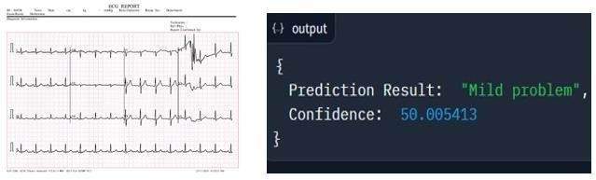

Fig. 9. Input and Output

CONCLUSION
This study offers analysis of feature extraction techniques, diverse datasets, preprocessing methodologies, and electrocardio- gram (ECG) images. It also carries out a thorough comparative analysis to evaluate the diagnostic efficacy of both state-of-the-art deep learning models, such as the Long Short-Term Memory (LSTM) network, and traditional algorithms. This comparative analysis lays the groundwork for a deeper examination of cardiovascular health analytics with the goal of pushing the envelope of present diagnostic capabilities and opening new avenues for future developments in medical diagnostics.As we move forward, the validation procedure is essential to guaranteeing the dependability and strength of the suggested approaches. The work tackles the requirement for consistent performance across diverse situations by means of validation on discrete datasets that reflect different illness presentations.

𝑹𝑬𝑭𝑬𝑹𝑬𝑵𝑪𝑬𝑺
- Abubaker, M. B., Babayi˘git, B. (2022). Detection of cardiovascular diseases in ECG images using machine learning and deep learning methods. IEEE Transactions on Artificial Intelligence, 4(2), 373-382.

- Ullah, T., Ullah, S. I., Ullah, K., Ishaq, M., Khan, A., Ghadi, Y. Y., Algarni, A. (2024). Machine Learning-Based Cardiovascular Disease Detection Using Optimal Feature Selection. IEEE Access.
- Henein, M. Y., Vancheri, S., Longo, G., Vancheri, F. (2022). The role of inflammation in cardiovascular disease. International journal of molecular sciences, 23(21), 12906.
- Ullah, X. Chen, K. Rajab, M. Al Reshan, A. Shaikh, M. Hassan, M. Rizwan,and M. D´avidekov´a, “An efficient machine learning model based on improved features selections for early and accurate heart disease predication,” Computational Intelligence and Neuroscience, vol. 2022, pp. 1–12, 07 2022
- G. Sailasya and G. Kumari, “Analyzing the performance of stroke prediction using ml classification algorithms,” International Journal of Advanced Computer Science and Applications, vol. 12, 01 2021.
- Garg, B. Sharma, and R. Khan, “Heart disease prediction using machine learning techniques,” IOP Conference Series: Materials Science and Engineering,vol. 1022, p. 012046, jan 2021.
- Townsend, N., Kazakiewicz, D., Lucy Wright, F., Timmis, A., Huculeci, R., Torbica, A., ... Vardas, P. (2022). Epidemiology of cardiovascular disease in Europe. Nature Reviews Cardiology, 19(2), 133-143.
- Jankowski, J., Floege, J., Fliser, D., Bo¨hm, M., Marx, N. (2021). Cardiovascular disease in chronic kidney disease: pathophysiological insights and therapeutic options. Circulation, 143(11), 1157-1172.
- Timmis, A., Vardas, P., Townsend, N., Torbica, A., Katus, H., De Smedt, D., ... Achenbach,
S. (2022). European Society of Cardiology: cardiovascular disease statistics 2021. European heart journal, 43(8), 716-799.
- Hill, M. A., Yang, Y., Zhang, L., Sun, Z., Jia, G., Parrish, A. R., Sowers, J. R. (2021). Insulin resistance, cardiovascular stiffening and cardiovascular disease. Metabolism, 119, 154766.
- Matsushita, K., Ballew, S. H., Wang, A. Y. M., Kalyesubula, R., Schaeffner, E., Agarwal, R. (2022). Epidemiology and risk of cardiovascular disease in populations with chronic kidney disease. Nature Reviews Nephrology, 18(11), 696-707.
- Vogel, B., Acevedo, M., Appelman, Y., Merz, C. N. B., Chieffo, A., Figtree, G. A., ... Mehran,
R. (2021). The Lancet women and cardiovascular disease Commission: reducing the global burden by 2030. The Lancet, 397(10292), 2385-2438.
- Joshi, A., Rienks, M., Theofilatos, K., Mayr, M. (2021). Systems biology in cardiovascular disease: a multiomics approach. Nature Reviews Cardiology, 18(5), 313-330.
- Nielsen, R. E., Banner, J., Jensen, S. E. (2021). Cardiovascular disease in patients with severe mental illness. Nature Reviews Cardiology, 18(2), 136-145.
- O’Kelly, A. C., Michos, E. D., Shufelt, C. L., Vermunt, J. V., Minissian, M. B., Quesada, O., ... Honigberg, M. C. (2022). Pregnancy and reproductive risk factors for cardiovascular disease in women. Circulation research, 130(4), 652-672.

